**ABSTARCT METHODS**

An abstract method is a method that is declared without an implementation. In Java, abstract methods are declared using the abstract keyword, and they must be defined in an abstract class or an interface. The primary purpose of an abstract method is to be overridden by subclasses or implementing classes, providing a mechanism for defining a contract that must be fulfilled by any concrete class that inherits from the abstract class or implements the interface.

### **Characteristics of Abstract Methods**

1. **No Implementation:** Abstract methods do not have a body. They only have a method signature (name, parameters, and return type).
2. **Abstract Classes and Interfaces:** Abstract methods can only be declared in abstract classes or interfaces. An abstract class can contain both abstract and non-abstract methods, while an interface can contain abstract methods (implicitly, without the abstract keyword) and default methods (methods with a default implementation).

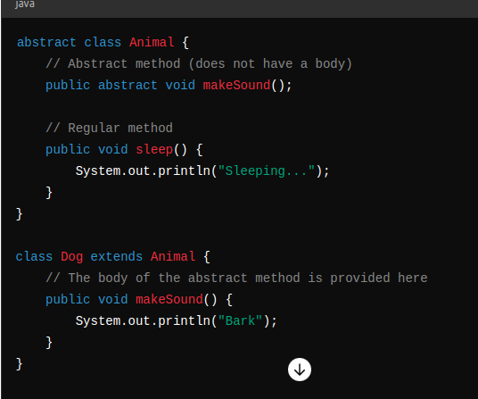

**Abstract method in interfaces**

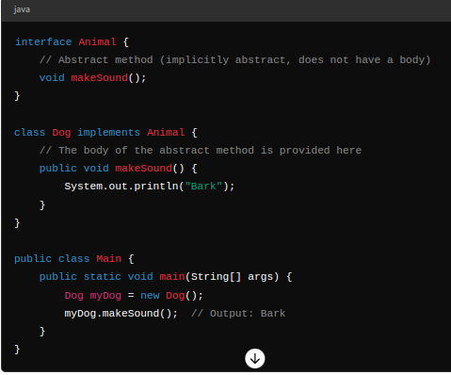

* **Abstract methods provide a way to enforce that certain methods are implemented by subclasses or implementing classes.**
* **Abstract methods are useful in defining a common interface for a group of related classes.**
* **An abstract class cannot be instantiated directly. It must be subclassed, and its abstract methods must be implemented by the subclass.**
* **An interface also cannot be instantiated directly. It must be implemented by a class, which then provides implementations for the interface's abstract methods.**